# Network Traffic Analysis - Week 5 Project

Course: ITS4211  
Student: Isaac Caballero  
Date: 10FEB25

## Project Objectives

The objective of this week's project is to complete network traffic analysis tasks within the Project Ares Battle School environment. Tasks include analyzing captured packets, identifying IP addresses, and extracting relevant data using tools on the Kali Linux virtual machine.

**Tasks Overview:**

1. **Network Analysis (Tasks 15-29):**
   * Analyze a PCAP file (NetworkTraffic.pcap) using tools in Kali Linux.
   * Access the Q&A Portal via the QA_Portal.htm link on the Kali desktop.
   * Answer questions related to the PCAP file, including DNS records, SNMP services, database management systems, and IP addresses.

**Key Objectives:**

* **Objective 15:** Identify the type of DNS record that points between the domain name and IP address for the Exchange server.
* **Objective 16:** Determine the FQDN (Fully Qualified Domain Name) of the WDC exchange server.
* **Objective 17:** Count the number of PTR DNS queries and replies during the capture.
* **Objective 18:** Identify the IP address that the mail application resolves to.
* **Objective 19:** Find the domain name associated with the IP address 18.6.0.9.
* **Objective 20:** Determine the launch IP address of the SNMP service attack.
* **Objective 21:** Identify the SNMP community string enumerated by the attacker.
* **Objective 22:** Determine the version number of the Linux firmware from the SNMP service.
* **Objective 23:** Identify the Linux command used to gather packets on the server based on the SNMP conversation.
* **Objective 24:** Find the intended recipient of the US Tax Policy Enabled Blog document from the SMB service.
* **Objective 25:** Identify the Relational Database Management System (RDBMS) used within the Washington network.
* **Objective 26:** Determine the IP address that hosts the database.
* **Objective 28:** Find the password for the database user in repeated hexadecimal format.
* **Objective 29:** Identify the name of the database where Personal Identifiable Information (PII) is stored.

## Approach and Execution

1. Logged into the Project Ares portal and launched the Battle School game.  
2. Entered the Battle Room and initiated the Network Traffic Analysis module.  
3. Connected to the Kali Linux virtual machine via VNC session.  
4. Opened the provided NetworkTraffic.pcap file and used tools such as Wireshark and command-line utilities to extract necessary information.  
5. Accessed the Q&A portal and submitted answers for tasks 15-29.  
6. Captured screenshots of each completed objective for documentation.

## Challenges and Solutions

One of the challenges faced was filtering through the network capture to find specific queries. To overcome this, advanced filtering techniques in Wireshark were applied, and command-line tools such as tcpdump and tshark were used to refine searches efficiently.

## Benefits of Additional Resources

The resources in the Media Center provided useful background on packet analysis techniques, which helped in interpreting network traffic data. The Game Room activities were beneficial for honing hands-on skills with various network security tools.

## Screenshots and Results

Screenshot: w5 br 4.png

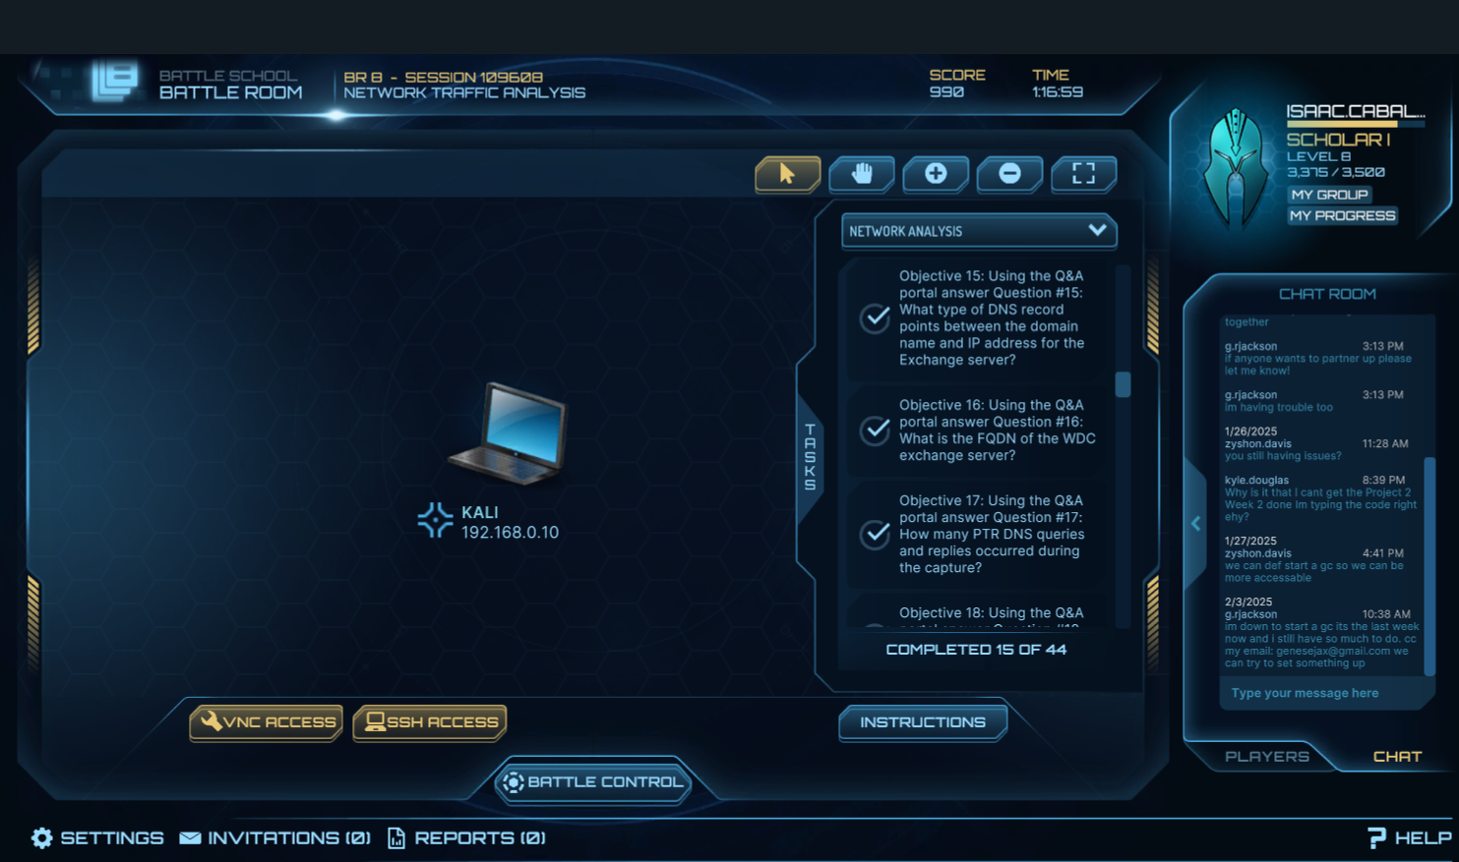

Screenshot: w5 br 3.png

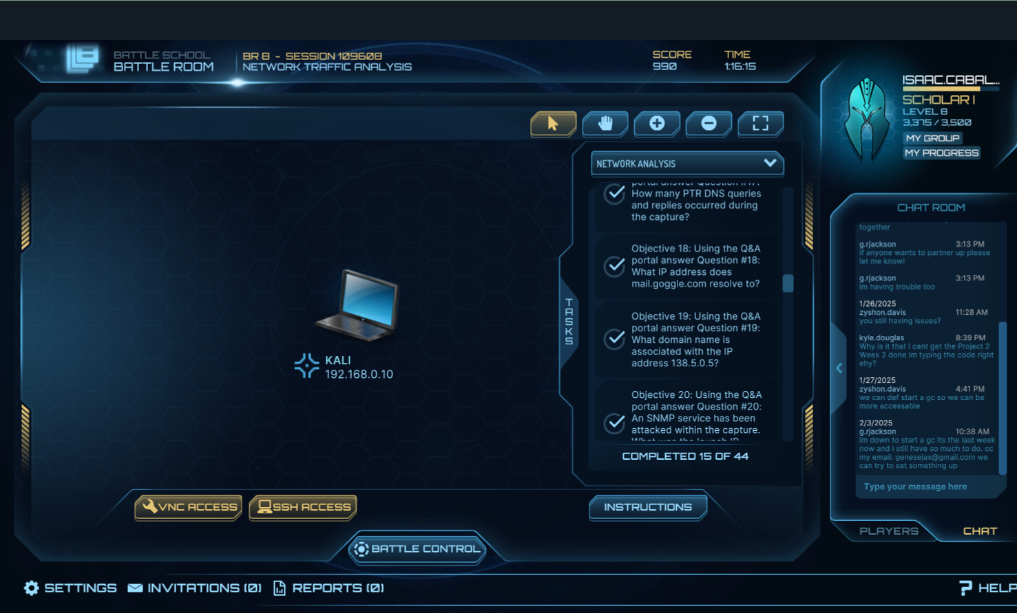

Screenshot: w5 br 2.png

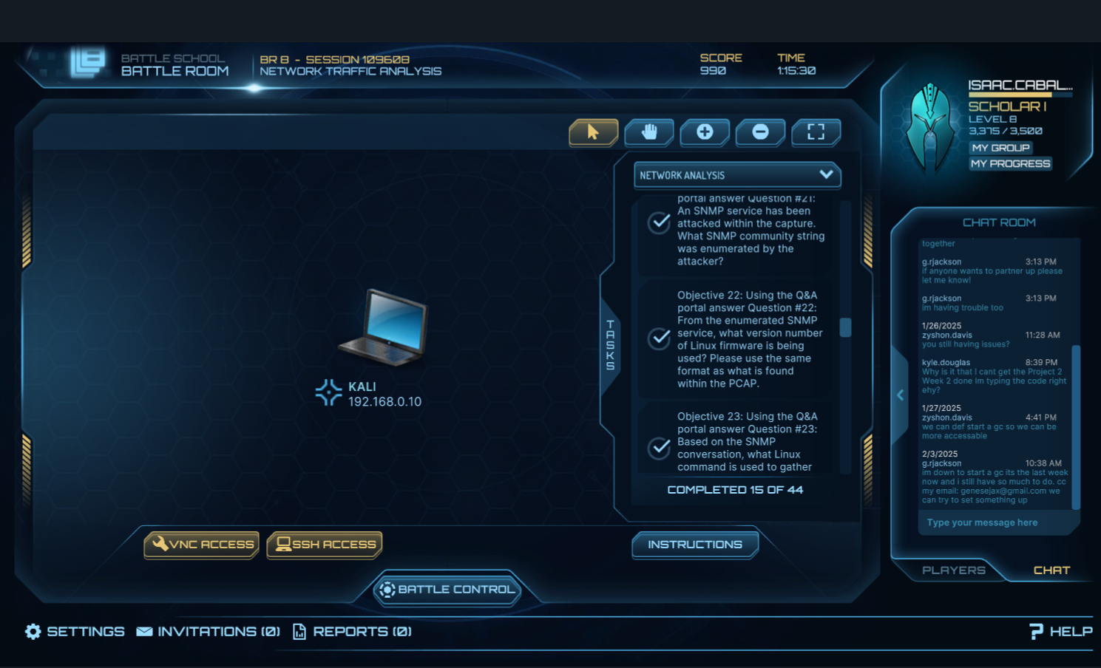

Screenshot: w5 br 1.png

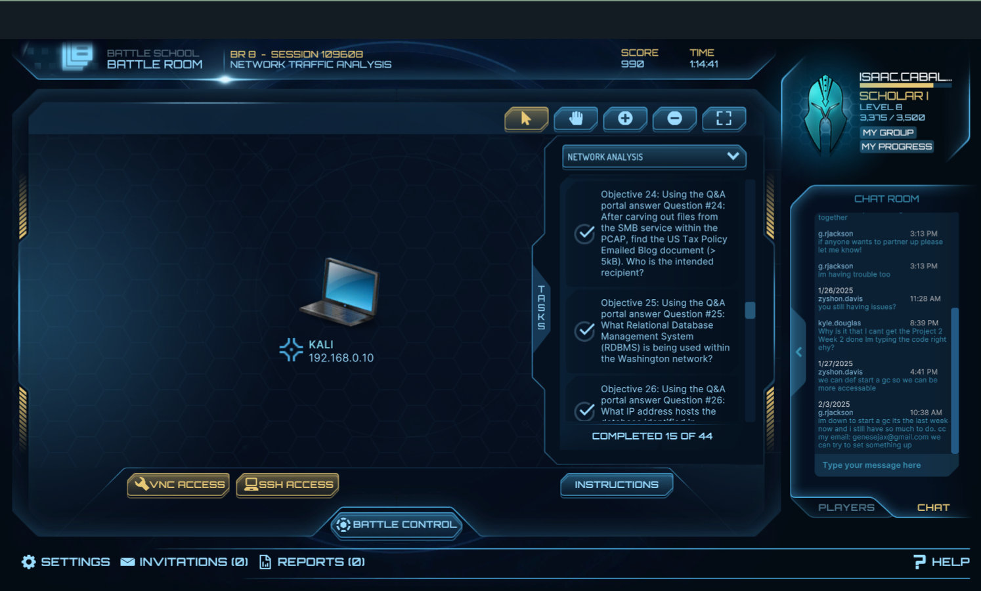

Screenshot: w5 br.png

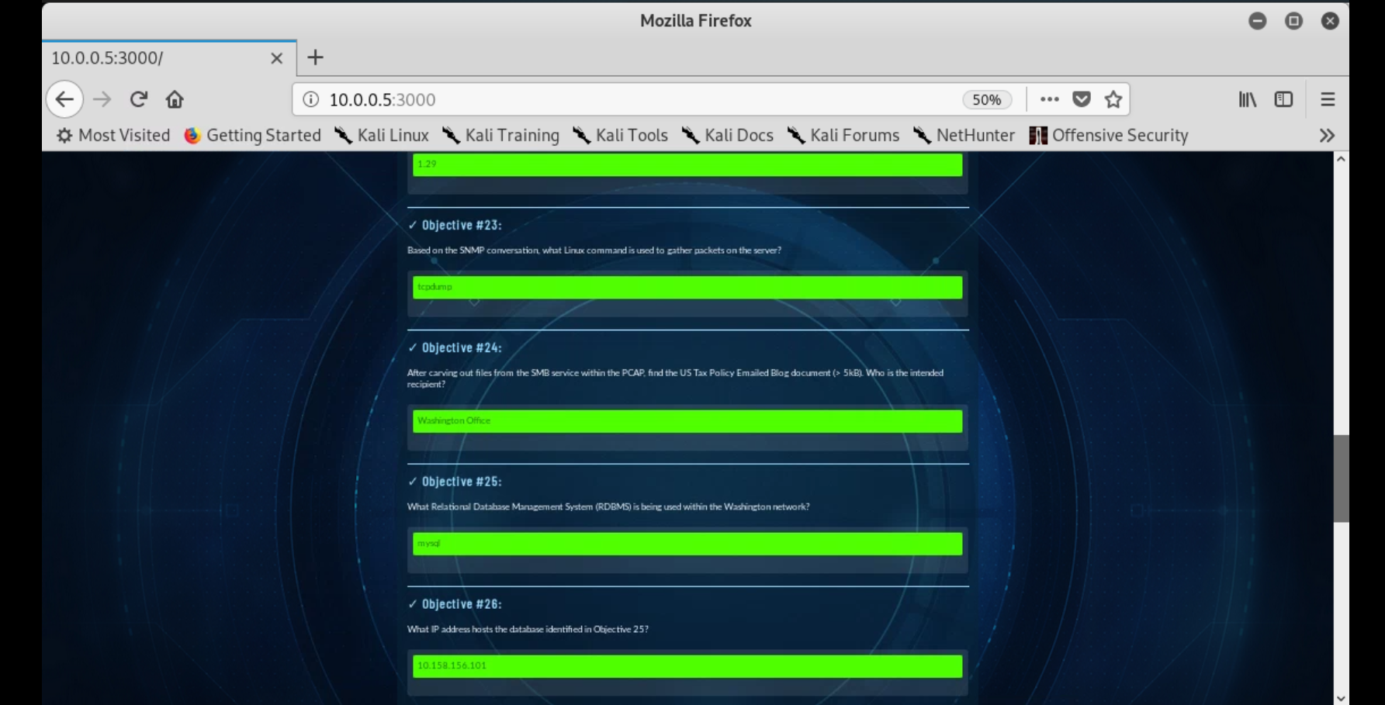

Screenshot: w5 project 4.png

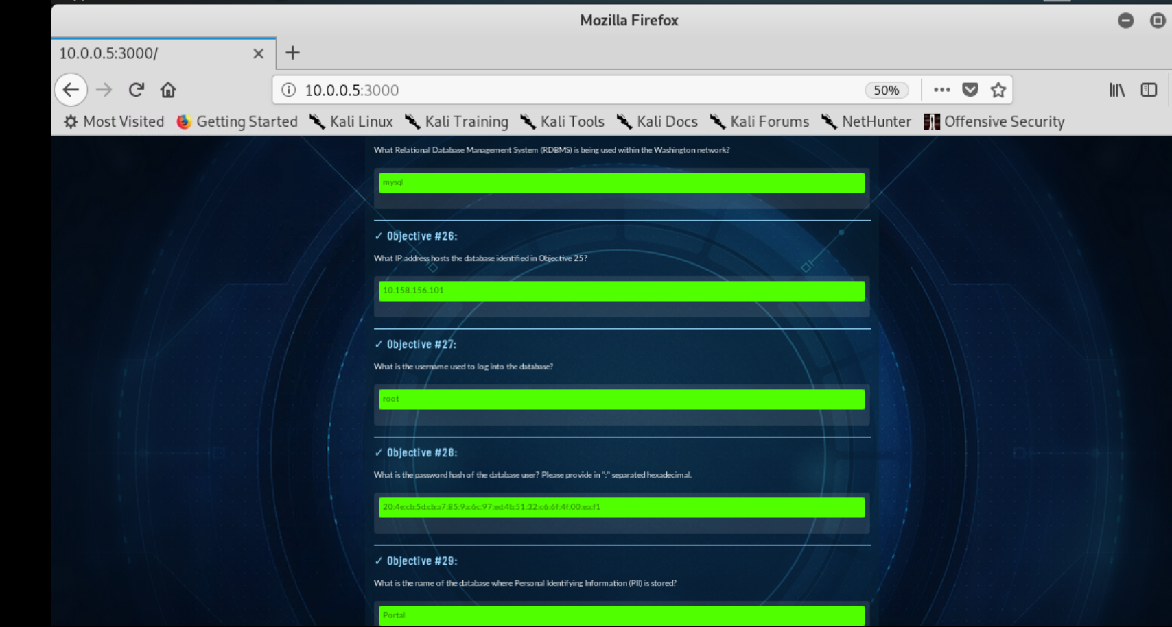

Screenshot: w5 project 3.png



Screenshot: w5 project 2.png

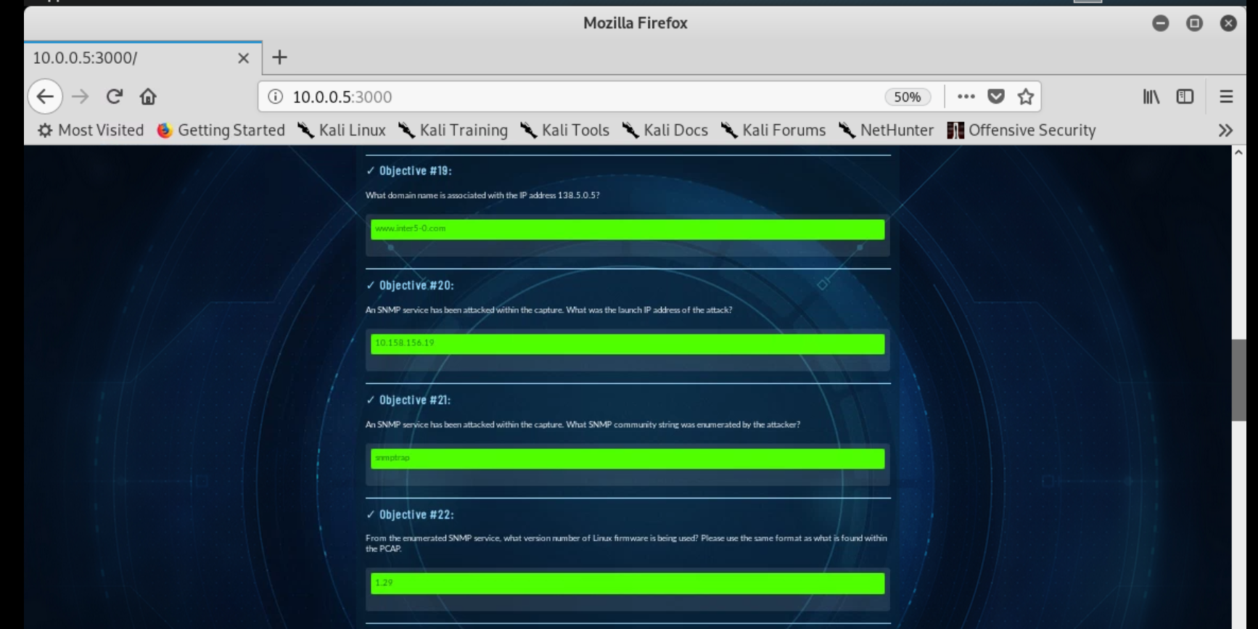

Screenshot: week 5 project .png

